**Reference No:** C37…..

**Damage Report Date:** .12/06/14...

**Incidents must be reported immediately.**

Damage found in Container must not to be touched until pictures have been taken to effectively demonstrate to stake holders how damage could have occurred?

In Transit Invoice No. AIRFREIGHT - ATG604

In Warehouse How was it damaged? Forklift

Product

RXV677B x4 S/N (21)Y113524QS ; (21)Y113294QS ; (21)Y113014QS ; (21)Y113304QS

*Insert* Picture:

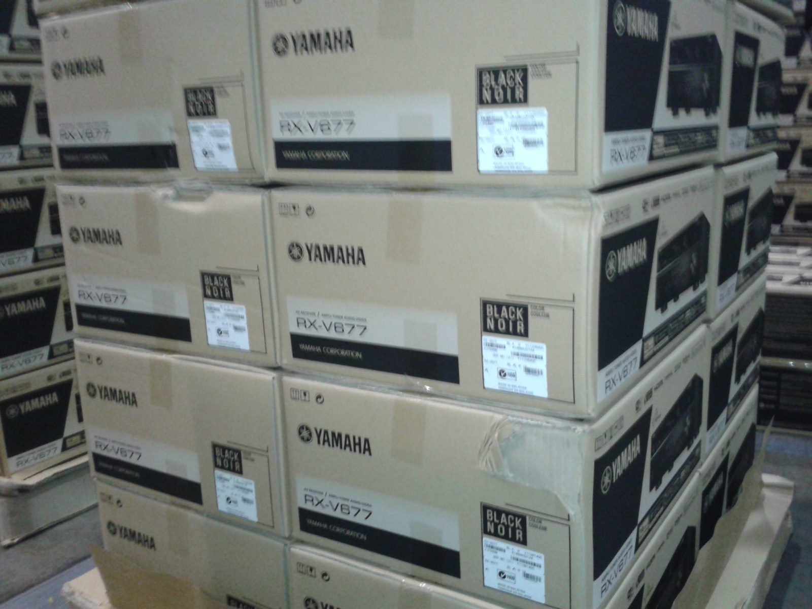

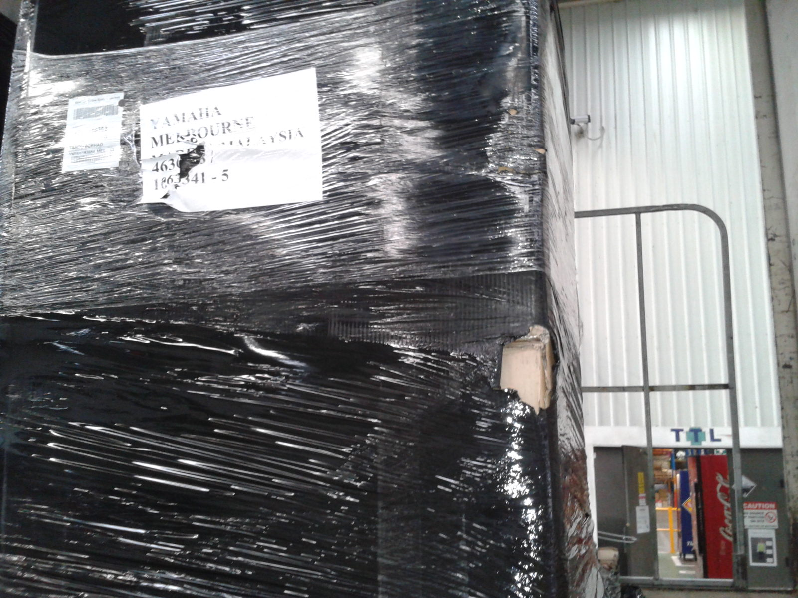

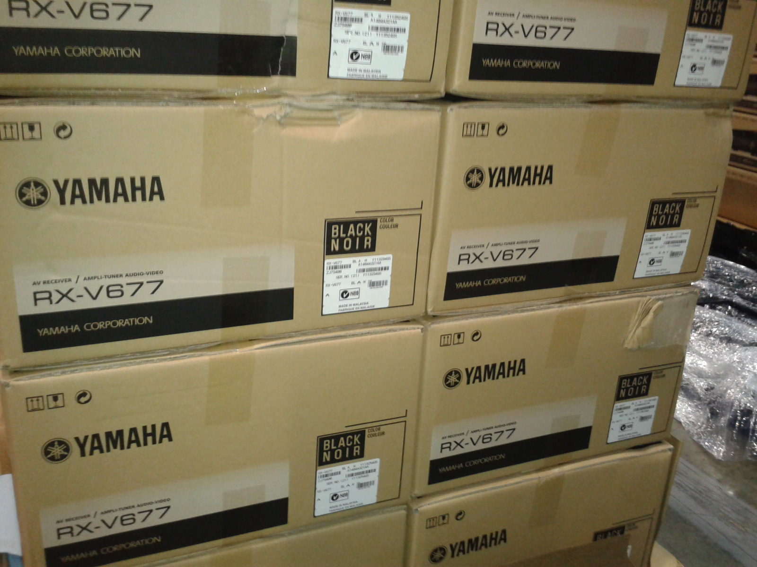

Reported by…Kesi…………………………………….